H.T No
Regulations:
A17

Sreenidhi Institute of Science and Technology
(An Autonomous Institution)
Code No: 6C303 Date: 05-Aug-2023 (FN)

B.Tech II-Year I- Semester External Examination, Aug - 2023 (Supplementary)
Probability Theory and Stochastic Process (ECE & ECM)

Time: 3 Hours Max.Marks:75

Note: a) No additional answer sheets will be provided.
b) All sub-parts of a question must be answered at one place only, otherwise it will not be valued.
c) Missing data can be assumed suitably.

Bloom's Cognitive Levels of Learning (BCLL)

Remember | L1 | Apply | L3 | Evaluate | L5
Understand | L2 | Analyze | L4 | Create | L6

Part - A Max.Marks:25
Answer all QUESTIONS

 |  | BCLL | CO(s) | Marks
1 | State Baye’s theorem. | L1 | CO1 | [2M]
2 | Write any three properties of the Gaussian random variable. | L2 | CO2 | [2M]
3 | The joint probability density function of two random variables 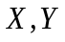 is given by  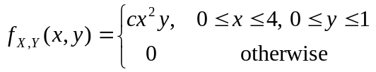  find the value of | L3 | CO3 | [2M]
4 | Determine the mean of the process 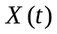, for which the autocorrelation function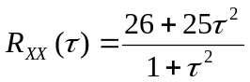 | L3 | CO4 | [2M]
5 | Show that the autocorrelation function has maximum value at the origin. | L3 | CO5 | [2M]
6 | Write the relation between Power spectrum and Auto correlation. | L2 | CO6 | [3M]
7 | Define discrete random variable. | L1 | CO2 | [3M]
8 | Define uncorrelated random variables. | L1 | CO4 | [3M]
9 | Define average power of a random process. | L1 | CO6 | [3M]
10 | Define moments of a random variable. | L2 | CO2 | [3M]
Part – B Max.Marks:50
ANSWER ANY FIVE QUESTIONS. EACH QUESTION CARRIES 10 MARKS.

 |  |  | BCLL | CO(s) | Marks
11. | a) | If 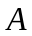and 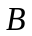are events such that 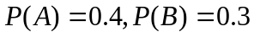and 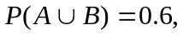find (i) 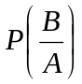 (ii) 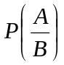 | L3 | CO1 | [5M]
 | b) | Suppose 5 men out of 100 and 25 women out of 10,000 are color blind. A color blind person is chosen at random. What is the probability of the person being a male (assume that male and female to be in equal numbers). | L4 | CO1 | [5M]
12. | a) | For the Uniform random variable with density function 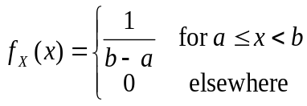  find (i) 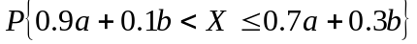 (ii) 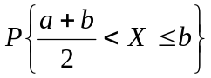 | L5 | CO2 | [5M]
 | b) | For a Gaussian random variable  having 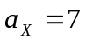and 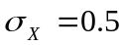 compute the probabilities of the events (i) 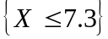 (ii)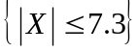 | L3 | CO2 | [5M]
13. | a) | Define joint distribution function and write its properties. | L2 | CO3 | [5M]
 | b) | The joint probability density function of two random variables is given by 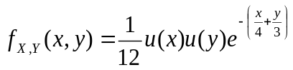. Show that 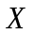 and are independent. | L3 | CO3 | [5M]
14. | a) | Explain Autocorrelation function of a random process. | L3 | CO4 | [5M]
 | b) | Given the autocorrelation function, for a stationary ergodic process with no periodic components, is 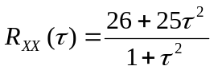. Determine the mean and variance of the process | L4 | CO4 | [5M]
15. | a) | Show that the random process 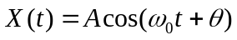is wide-sense stationary if it is assumed that  and 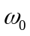 are constants and is a uniformly distributed random variable on (0, 2π) | L3 | CO5 | [5M]
 | b) | Derive the relationship between cross-power spectral density and cross correlation function. | L2 | CO5 | [5M]
16. | a) | Derive the relation between input PSD and output PSD of an LTI system | L2 | CO6 | [5M]
 | b) | If 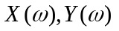 and 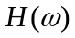are the respective Fourier transforms of input signal 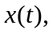 response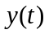 and network’s impulse response 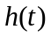, show that 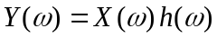 | L3 | CO6 | [5M]
17. | a) | Determine the mean and variance of exponentially distributed density function 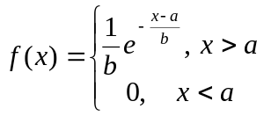 | L3 | CO1 | [5M]
 | b) | The joint density function of and is 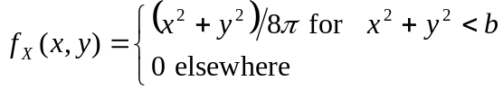  find (i)(ii) 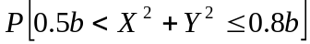 | L5 | CO2 | [5M]
18. | a) | Explain cross correlation of two random processes. | L2 | CO4 | [5M]
 | b) | Calculate the equivalent noise bandwidth of an RC Low pass filter. How it is related to its 3 db Bandwidth. | L3 | CO5 | [5M]
-- 00 -- 00 –

